Geometric Lift of Negative Holographic Evolution
  - Preserving the negative Hamilton–Jacobi direction while enforcing positive completed operation
Joseph Shields
28 July 2026
Working paper

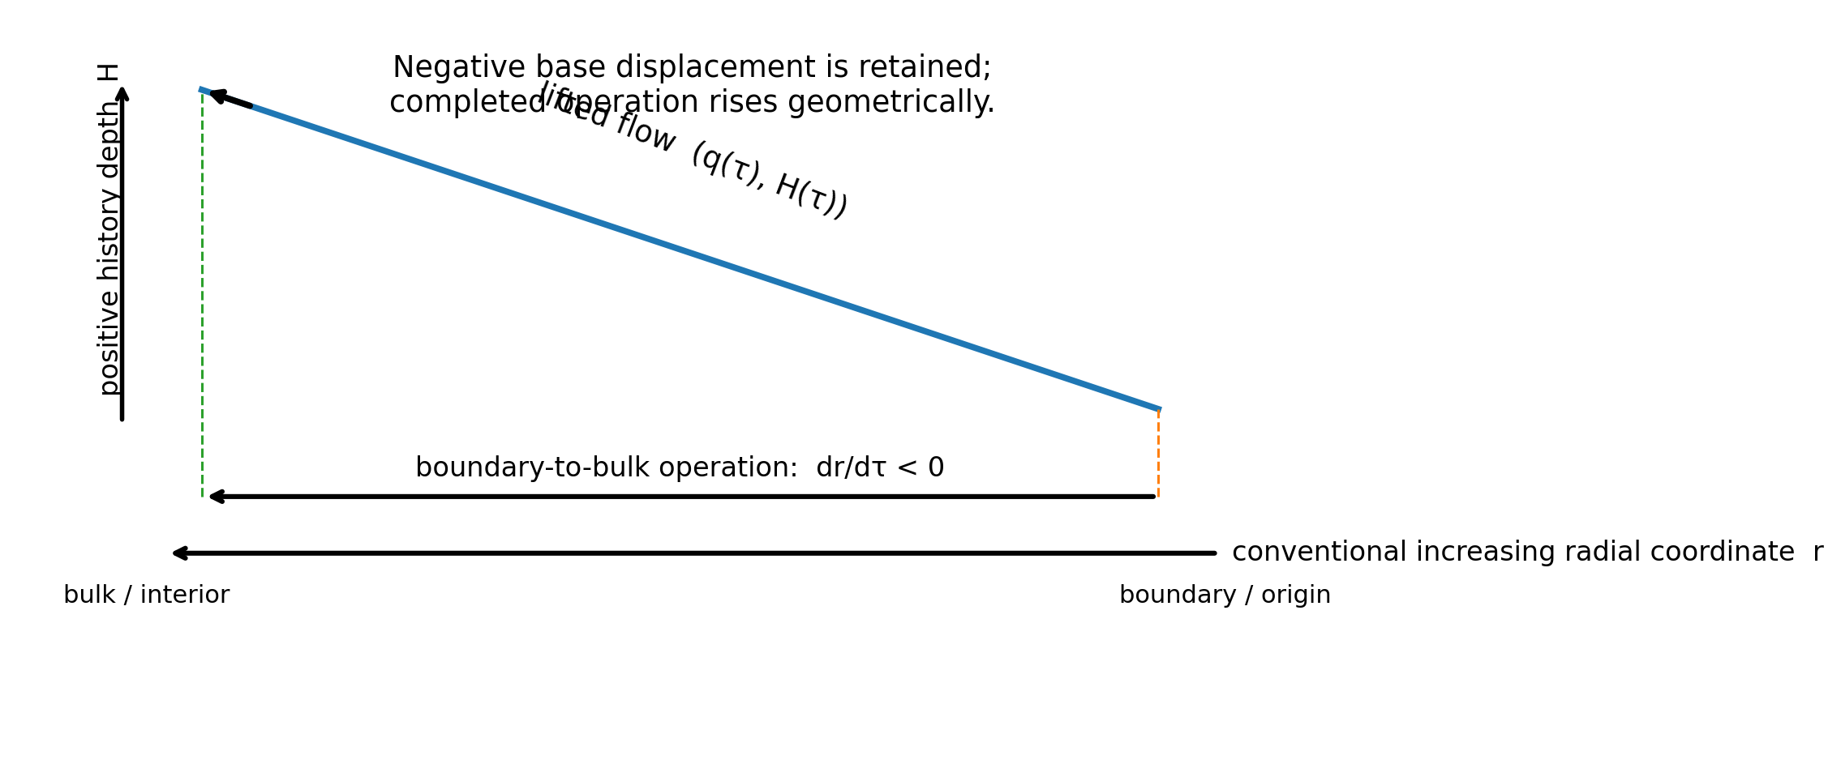
Figure 1. The radial coordinate decreases while the lifted history coordinate increases.

Abstract
Boundary-to-bulk reconstruction in Hamilton–Jacobi formulations of AdS/CFT follows the negative of the conventionally outward radial vector field. A previous treatment converted this sign-definite decrease into a positive accumulated quantity by defining a separate positive-evolution integral. The present paper gives a stronger geometric formulation. The negative flow is not altered, discarded, or made positive by fiat. Instead, the configuration space is lifted by adjoining a monotone history coordinate. The original operator remains negative in the base space, while its lifted trajectory has a strictly positive component in the new history direction. Thus a backward-oriented radial displacement and a forward completed operation are represented simultaneously as components of one geometric flow. The construction is exact, applies to any sign-definite first-order flow, and clarifies that positivity belongs to the accumulated operation rather than to every coordinate component of the underlying dynamics.
Keywords: AdS/CFT; Hamilton–Jacobi flow; holographic renormalization; geometric lift; positive evolution; Arrow of Time Operation Integrals; traversal depth.

1. The point of the construction
The relevant holographic calculation already contains two different notions that are easily collapsed into one. The radial state can move in a negative coordinate direction, while the reconstruction that produces that motion is nevertheless a positively completed operation. The strongest treatment is therefore not to remove the negative sign. It is to retain the negative sign exactly where it belongs and raise the complete operation into a geometry that also records how much traversal has occurred.
base displacement: dq/dτ = −F(q)
completed operation: dH/dτ ≥ 0
The first equation states where the system moves in the original configuration space. The second states that an operation initiated at an origin has accumulated rather than un-happened. These statements are compatible because they refer to different components of the same lifted trajectory.

2. Negative boundary-to-bulk evolution
Let q denote the Hamilton–Jacobi boundary data, including the induced metric and matter fields on a radial slice. Write the conventionally outward first-order radial flow as
dq/dr = F(q).
Choose the boundary slice r = r∂ as the operational origin and let τ increase inward into the bulk:
τ = r∂ − r, dr/dτ = −1.
The chain rule then gives
dq/dτ = (dq/dr)(dr/dτ) = −F(q).
Nothing has crossed outside the radial interval, and no physical law has been reversed. The negative sign records that the operation is traversing the same radial curve opposite to the conventional increasing-r orientation.

3. Why sign replacement is weaker than geometric lifting
A scalar rectification may define a positive accumulated quantity from a negative rate. If a scalar W obeys
dW/dτ = −σ(q), σ(q) ≥ 0,
one may define
E(τ) = ∫₀^τ σ(q(s)) ds, dE/dτ = σ(q) ≥ 0.
This is exact, but it can look as though the negative equation has been replaced by a positive one. The geometric lift avoids that appearance. It keeps W and E together:
W(τ) = W(0) − E(τ).
The negative coordinate change and the positive completed amount are therefore not rival descriptions. They are two projections of one enlarged state.

4. The positive-history lift
Let Q be the original Hamilton–Jacobi configuration space. Introduce the lifted space
Q̃ = Q × ℝ₊,
where the added coordinate H records traversal depth from the marked origin. Define
q̃(τ) = (q(τ), H(τ)), H(0) = 0.
Choose any nonnegative rate that faithfully measures completed motion. The most direct geometric choice is the speed of the base trajectory with respect to a positive metric G on the relevant configuration-space directions:
dH/dτ = ‖dq/dτ‖G = √[G(dq/dτ, dq/dτ)] ≥ 0.
For dq/dτ = −F(q), the lifted flow is
dq̃/dτ = (−F(q), ‖F(q)‖G).
The minus sign has not been dropped. It remains the first component of the lifted vector. Positivity appears as the second component, which measures the amount of operation completed along that negative base direction.

5. Geometric Lift Theorem
Theorem 1 (Positive-history lift of a signed flow). Let q:[0,T]→Q satisfy dq/dτ = V(q), and let v(q) be a continuous nonnegative function that is strictly positive wherever V(q)≠0. Define H(τ)=∫₀^τ v(q(s))ds and q̃(τ)=(q(τ),H(τ)). Then
dq̃/dτ = (V(q), v(q)), dH/dτ ≥ 0.
If the base flow is negative relative to a chosen orientation, V = −F, that sign remains unchanged in Q. Nevertheless, every nontrivial segment rises strictly in the H direction.
Proof. The first component follows from the original equation. The fundamental theorem of calculus gives dH/dτ=v(q(τ))≥0. If V is nonzero on a set of positive measure and v is positive there, then H(τ₂)>H(τ₁) for τ₂>τ₁ across that segment. Hence the lifted curve advances in history depth even where its base projection moves negatively, retraces, or returns.

6. The lifted operator
The construction may be written as a geometric lift of the original vector field rather than as a replacement operator. For a base vector field V, define
L₊[V](q,H) = (V(q), v(q)), v(q) ≥ 0.
Applied to the boundary-originated holographic flow:
L₊[−F] = (−F, v).
This is the precise form of ‘raising the operator’. The base operator remains −F. The lift embeds it into a higher-dimensional tangent space where the final component lies in the positive history direction. The lifted operator therefore respects positive operation without pretending that its radial component is positive.

7. Holographic choices for the history rate
The lift is structural; the choice of v determines what physical or operational quantity the added depth records. Several choices are available on a sign-definite holographic branch.
History rate | Meaning
v = ‖F‖G | Configuration-space arc length; the most direct geometric traversal depth.
v = −dW/dτ | Positive decrease of the Hamilton–Jacobi cosmological functional when dW/dτ≤0.
v = GIJ βIβJ | Positive holographic RG speed when the scalar target-space metric is positive definite.
v = |dℒ/dτ| | Total variation of a local action density, useful when a signed branch changes orientation.
On the potential-dominated branch used in the earlier holographic analysis, the scalar-gradient norm and the beta-function norm provide natural positive rates. The lift does not add a new bulk field or change Einstein’s equations. It augments the representation of the solution by retaining an accumulated readout of the operation.

8. Finite domains and dimensional incompleteness
Suppose the radial calculation is performed on a finite interval r∈[rIR,r∂]. The negative derivative dr/dτ=−1 exists throughout the interval and therefore cannot be attributed to leaving it. The deeper limitation is that the finite base domain records radial position but not necessarily traversal depth.
base domain: D = {q(r) : rIR ≤ r ≤ r∂}
lifted domain: D̃ = {(q(r),H) : rIR ≤ r ≤ r∂, H ≥ 0}.
A trajectory can stay entirely inside D in its first component while advancing into values of H that D does not represent. In this precise sense, the completed evolution lies outside the dimensional completeness of the base description, not outside its radial coordinate bounds.

9. Recurrence becomes vertical separation
The same lift also resolves the geometric ambiguity that appears when a base trajectory retraces or recurs. If
q(τ₂) = q(τ₁), τ₂ > τ₁,
but nonzero traversal occurred between them, then
H(τ₂) > H(τ₁),
and therefore
q̃(τ₂) ≠ q̃(τ₁).
The base projection may form a loop, repeat a slice, or collapse two endpoints into one label. In the lifted space those same points are vertically separated by completed history. A circle in the projection becomes a helix when the traversal coordinate is retained.

10. What the result does and does not claim
The construction does not claim that every negative derivative is secretly positive. It does not reverse a radial coordinate convention, discard a minus sign, alter the Hamilton–Jacobi constraint, or introduce an independent physical time into Euclidean AdS/CFT. It establishes a narrower statement: signed displacement and positive completion are compatible components of one lifted operation.
The history coordinate is derived from the path and origin. Its physical interpretation depends on the selected rate v and on the regime in which positivity is established. If the relevant metric is indefinite, the flow changes branch, or quantum and higher-derivative corrections spoil sign-definiteness, the rate must be reconsidered or defined through branchwise total variation.

11. Conclusion
Boundary-to-bulk holographic reconstruction need not be made positive by changing the sign of its radial operator. The negative Hamilton–Jacobi direction can be preserved exactly and lifted geometrically:
−F(q) ⟶ (−F(q), v(q)), v(q) ≥ 0.
The first component retains the actual direction of the radial calculation. The second records that the operation has accumulated from its marked boundary origin. Positive evolution is therefore not a corrected negative vector; it is the rising depth of a negative traversal.
This formulation is stronger than scalar sign rectification because it displays both facts at once. The system can move backward relative to one coordinate orientation while moving forward as an operation. The apparent conflict was produced only by asking one coordinate to represent both displacement and completion.

References
[1] J. M. Maldacena, “The Large N Limit of Superconformal Field Theories and Supergravity,” Advances in Theoretical and Mathematical Physics 2 (1998), 231–252. arXiv:hep-th/9711200.
[2] E. Witten, “Anti-de Sitter Space and Holography,” Advances in Theoretical and Mathematical Physics 2 (1998), 253–291. arXiv:hep-th/9802150.
[3] J. de Boer, E. Verlinde and H. Verlinde, “On the Holographic Renormalization Group,” Journal of High Energy Physics 08 (2000), 003. arXiv:hep-th/9912012.
[4] J. Shields, “Origin-Oriented Hamilton–Jacobi Flow and Observer-Preserving Time,” working paper (2026).
[5] J. Shields, “The Depth of Traversal,” working paper (2026).

